Statement of support

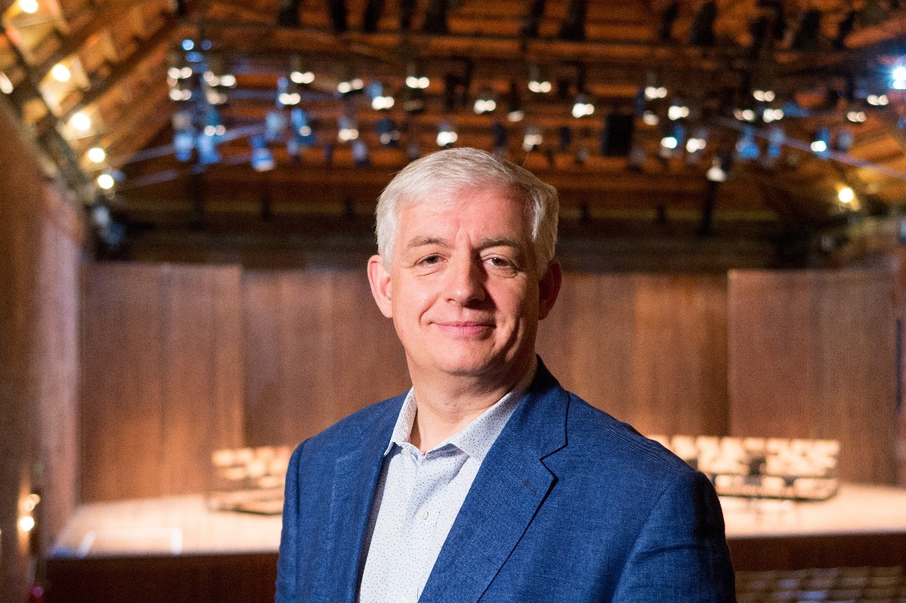
Roger Wright, CBE

I have long been fascinated by the intersection between composers and performers and the academic world, particularly that of humanities research.
It has always seemed to me that the world of creation and re-creation of music and other performing arts has always been the richer for the dialogue between its practitioners and those researching into elements of historical and contemporary context and perspective.
This is most obvious in the realm of performance practice but it is also vital in the imaginative world of new work creation.
I have experienced, in various organisations in which I have worked and with which I have been associated, the relevance of this research and practitioner interface. When I ran BBC Radio 3, the New Generations Artists scheme was created. After twenty years, this remains a unique talent development programme. Young professional performers at the start of their careers are given performance and recording opportunities to give them experience of the public exposure. It became clear that Radio 3, as a place and a station of ideas could benefit from a similar scheme for young academics and, in partnership with AHRC, New Generation Thinkers was formed and became an important and established part of the academic world and Radio 3’s programming.
These schemes, programmes and ideas do not exist in their individual boxes, but instead create a world in which there is a greater richness of discussion and output.
Music programming remains an intriguing art form in itself. Historical context and musicological research obviously plays an essential part in the thinking and planning of period instrument ensembles and organisations. The so called “early music movement” has been the most fast developing of the last fifty years. This has come about, not least through the partnership between musicians, musicologists and historians. An ongoing relationship between these groups has given a deeper understanding of the way in which historically informed performance style and practice has changed over the centuries. It has also provided the basis for debate about how public programmes might be shaped and delivered. We need performers to perform and we also need experts in history to inform our concert and operatic world and keep it refreshed in its approach to programming and the context in which events take place.
In my role as Director of the BBC Proms, I was intrigued by the concept of recreating programmes from earlier Proms seasons and also the concerts in which key works were premiered. Social and musical historians gave me insights into the audiences, socio-political dynamics and resulting atmosphere of the Proms events of previous eras. These insights gave me inspiration and ideas for the way in which the Proms could continue to innovate in general as well as creating individual programme ideas.
Our current work at the Snape Maltings creative campus involves leading year-round research and training. There has been a significant development in the way in which that work now regularly includes professionals from many different spheres who come together to share best practice. Musicians, academics and medical practitioners help develop our creative health programme. Musicologists work with chamber ensembles in our Britten-Pears Young Artist Programme as an essential part of their training. Scholars and language coaches help with the tutoring and mentoring of young singers to enable them to understand the linguistic and literary context of their repertoire.
These are not “nice to haves” but what I regard to be an essential interface between performance, composition and research.

